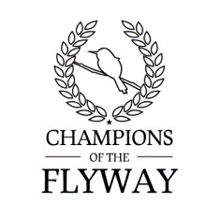
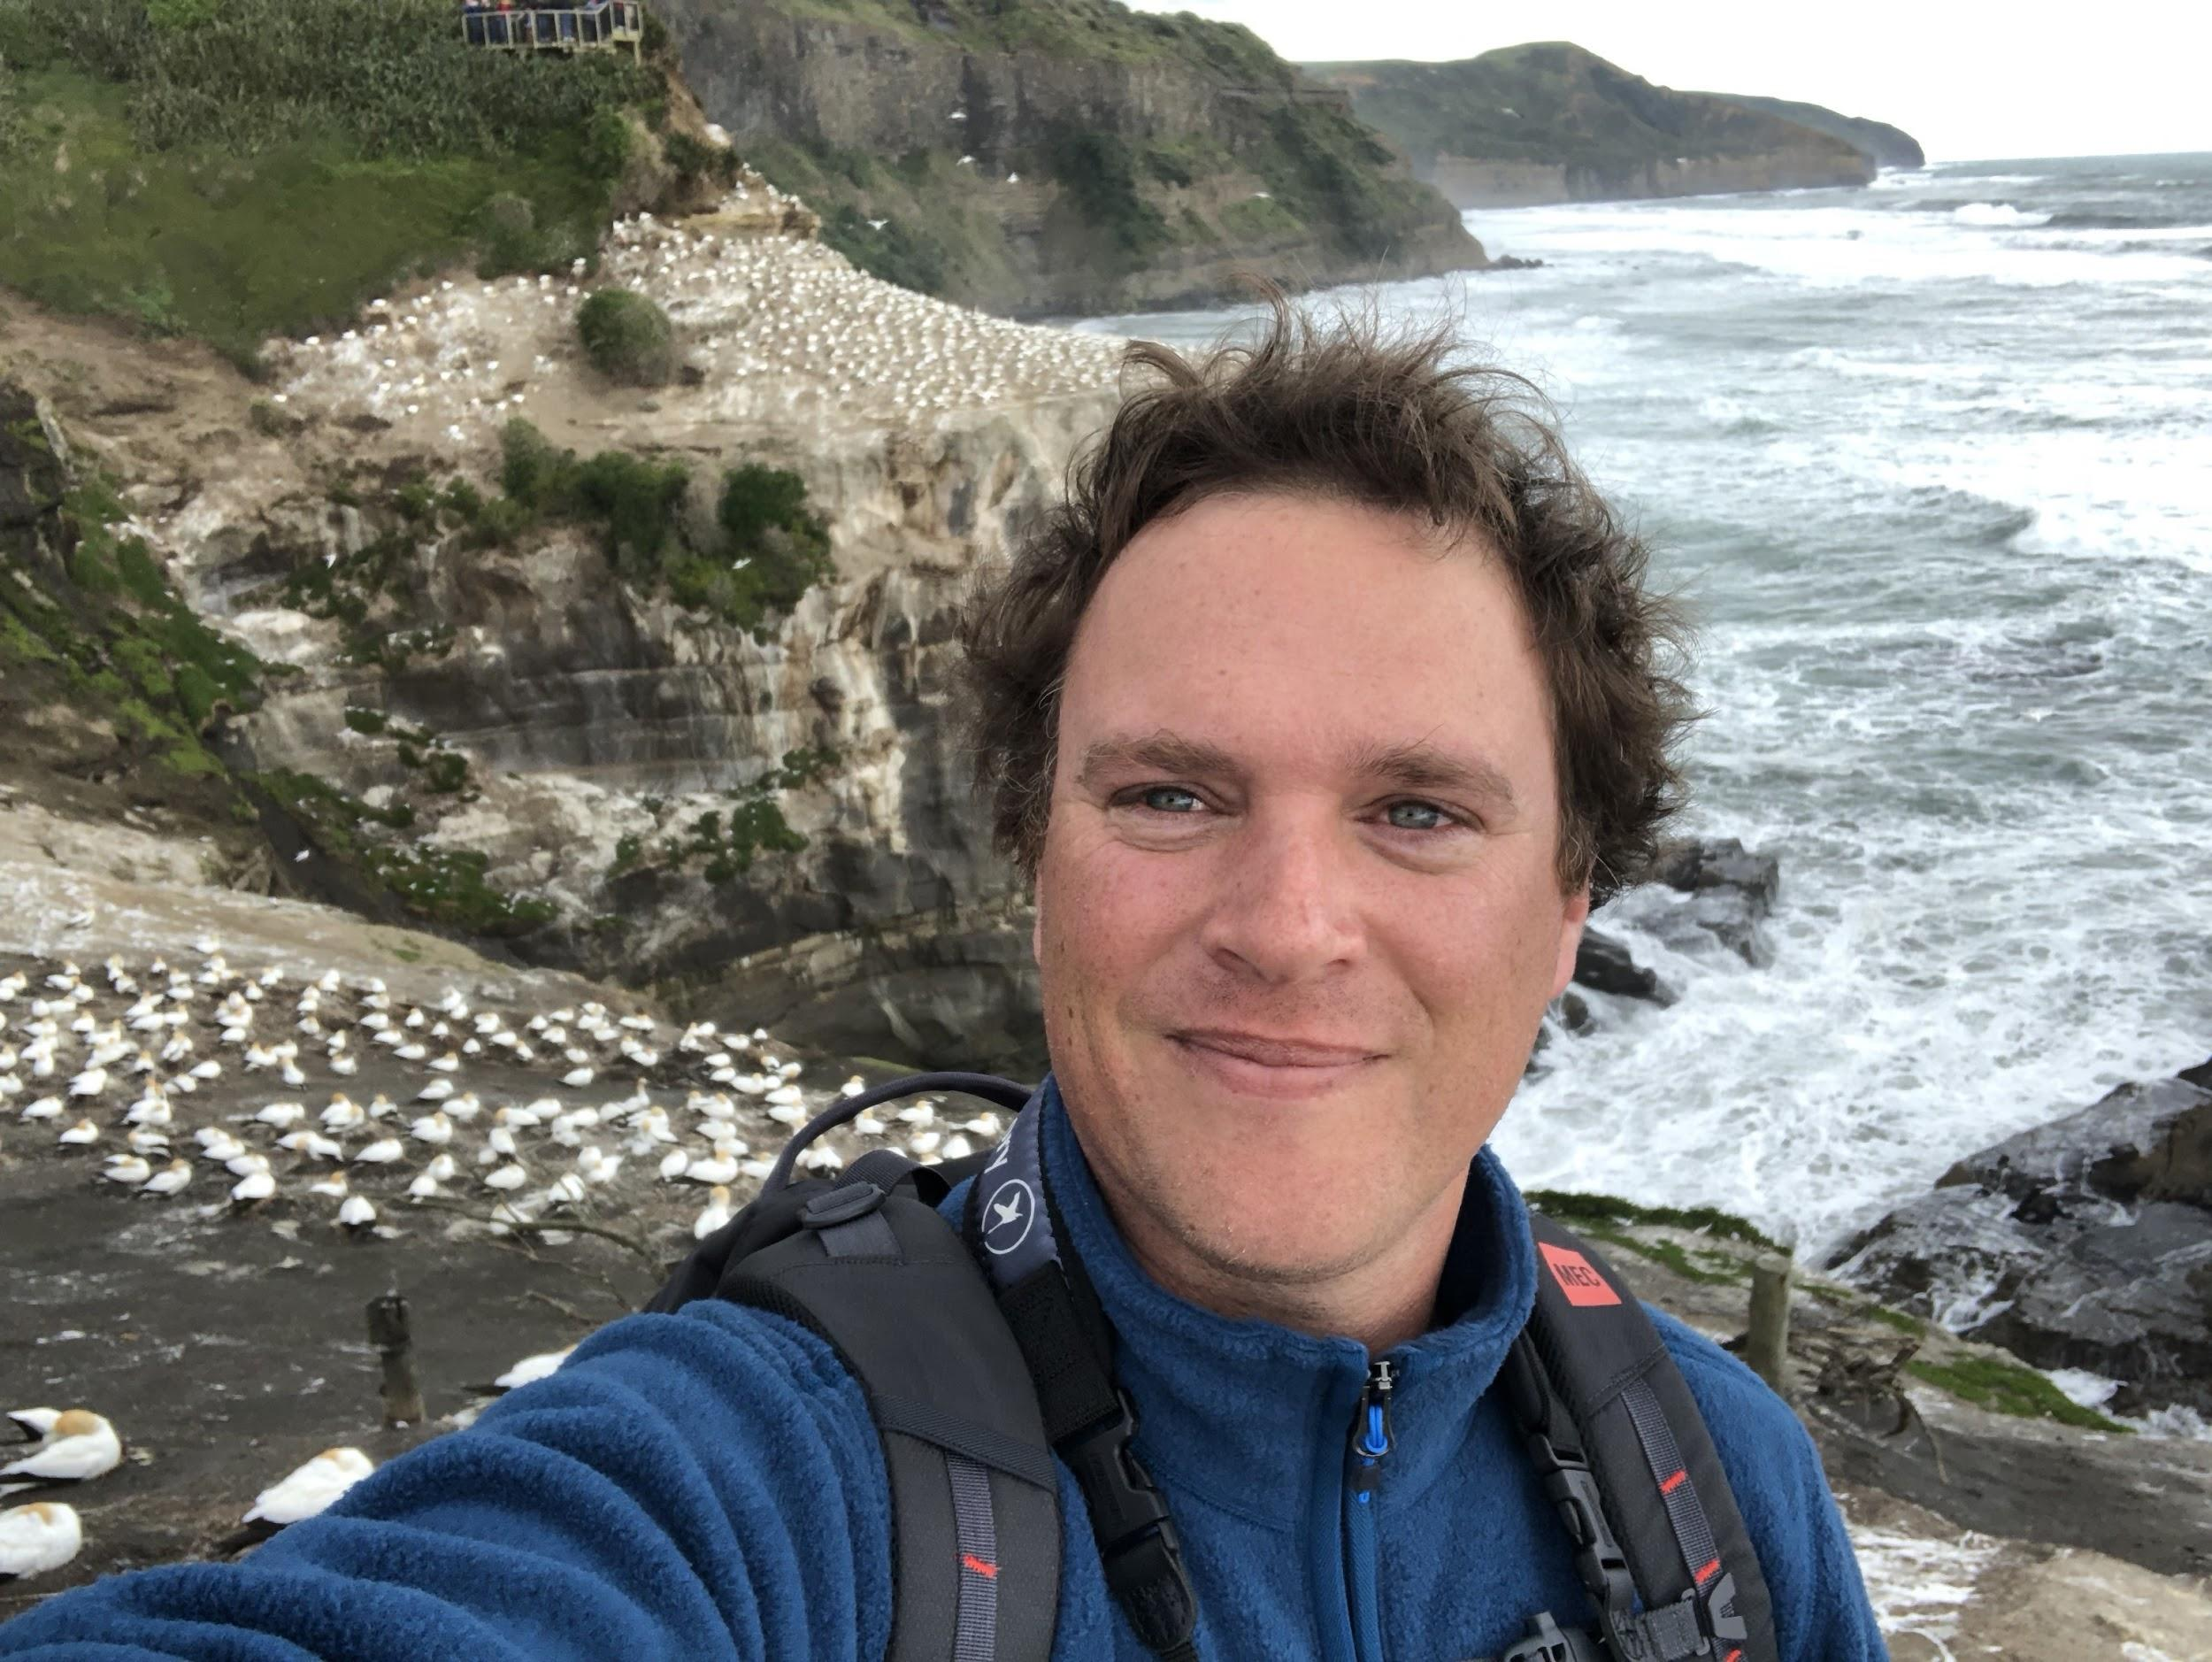

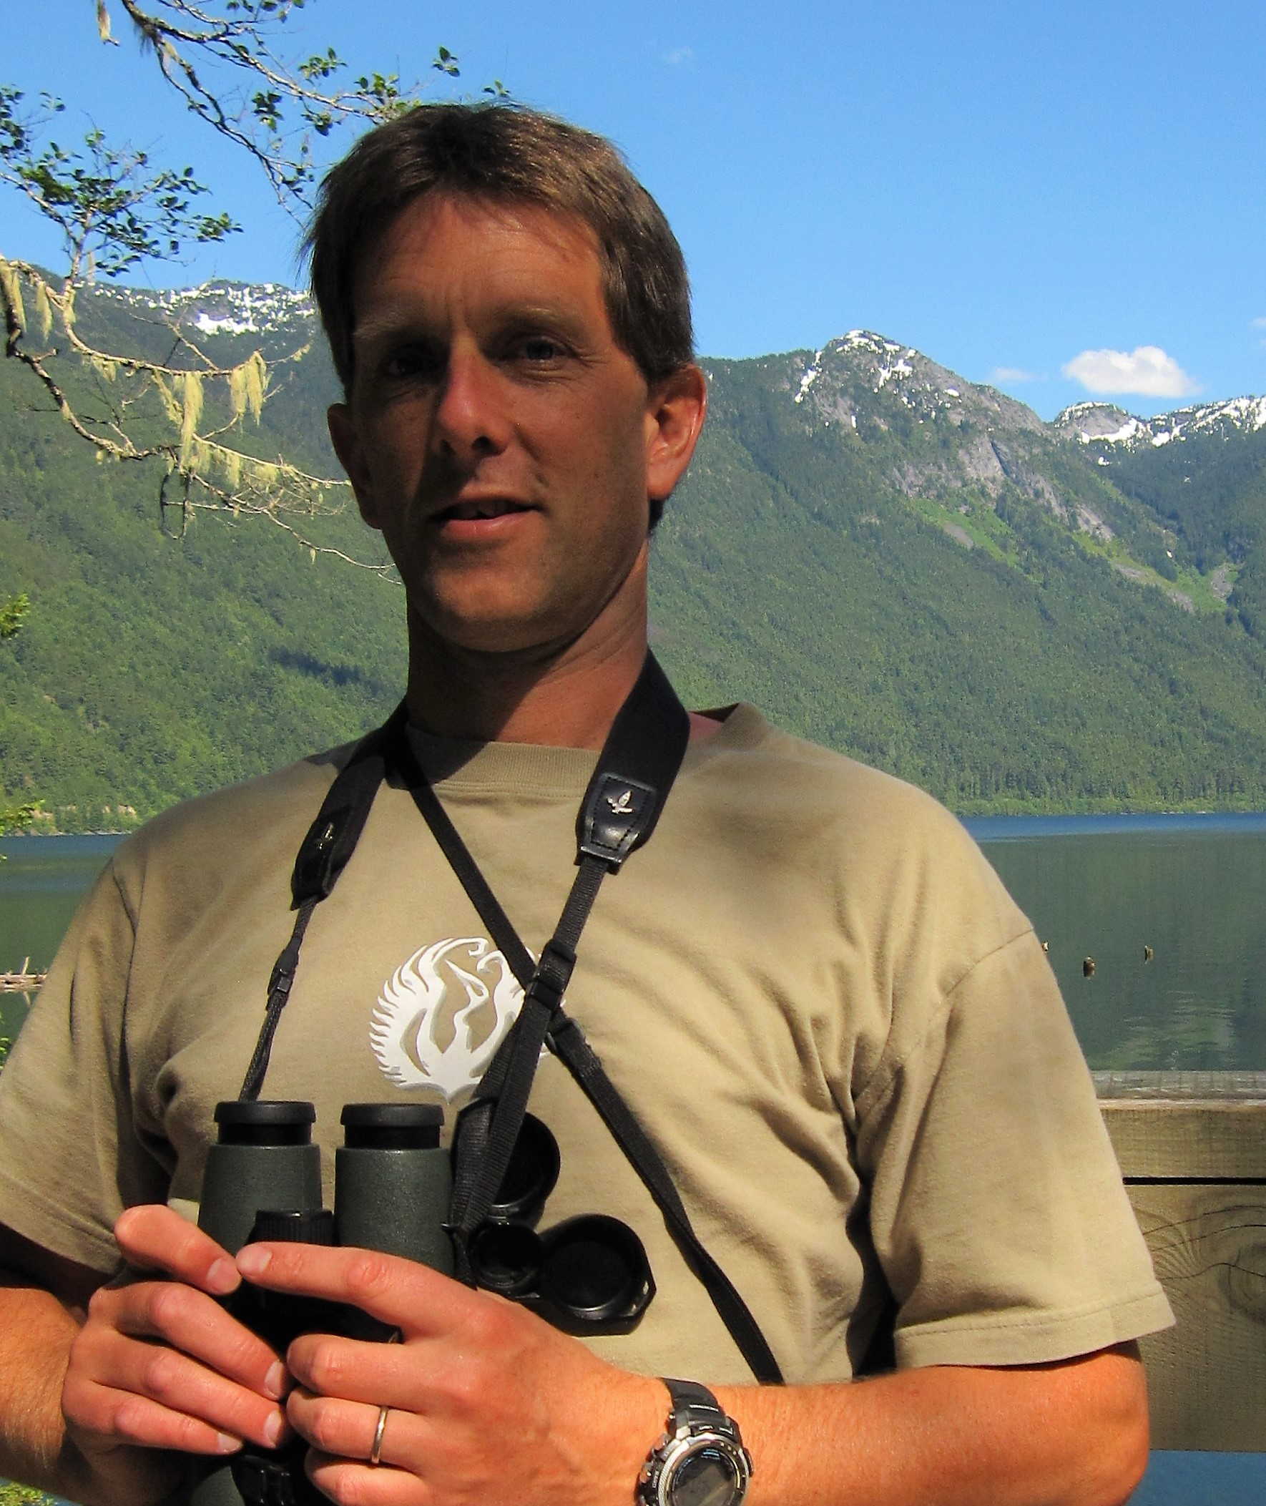
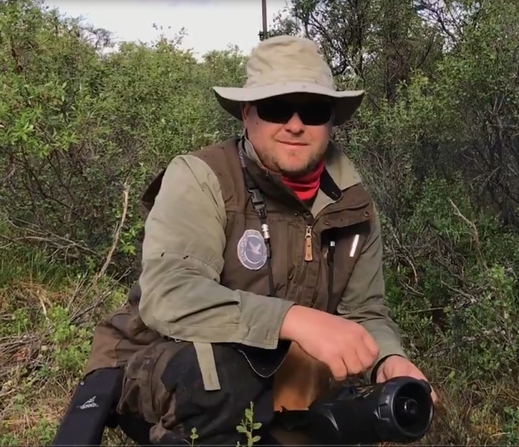
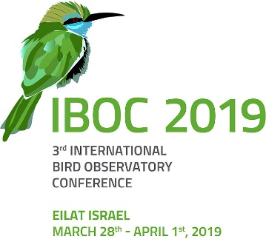

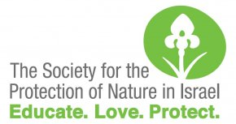


Meet the Canucks

Jody Allair is the National Advisor, Conservation Outreach for Bird Studies Canada. He delivers education and outreach programs to audiences across the country and is the coordinator for eBird Canada. He has banded owls on CBC’s Rick Mercer Report, has spoken about Canada Jays at Ideacity, is a regular contributor on the American Birding Association podcast, and has written numerous articles on birds, birding, and connecting with nature. In addition to his work at BSC, Jody is a Birding Tour Leader with Canadian-based Eagle-eye Tours.

Yousif Attia has had a prodigious preoccupation with the natural world since before he can remember. Originally from the banks ofthe Nile in North Africa; he grew up studying and searc hing for birds in the Canadian Rocky Mountains and prairies. Yousif is a birding guide with Eagle-Eye Tours, and an environmental consultant who specializes in mitigating the impacts of human development on wildlife. He is formerly a BSC Species-at-risk Biologist and Program Coordinator of the Long Point Bird Observatory.

Pete Davidson is Bird Studies Canada’s senior conservation advisor, formerly program manager for British Columbia. He is something of a long-distance migrant, originally from the UK, who arrived in Canada via a decade in Asia, is now a Metro Vancouver homeowner and permanent resident, although currently based remotely on the East Africa – Eurasia Flyway in Tanzania for much of his year. Pete is a lifelong birder, a passionate conservationist and brings a global perspective to BSC’s local-to-hemispheric conservation science program.

Stuart Mackenzie began exploring the natural world in the womb, and has been birding since the age of 2. He is Director, Migration Ecology at Bird Studies Canada (BSC) responsible for the Motus Wildlife Tracking System, Long Point Bird Observatory and aspects of the Canadian Migration Monitoring Network. He is the past-president of the Ontario Bird Banding Association and Chair of the North American Banding Council. He is a devote birder and naturalist with a special affinity for Long Point, Ontario.

